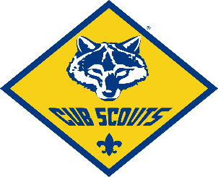
Cub Scout Pack 76 Spaghetti Dinner
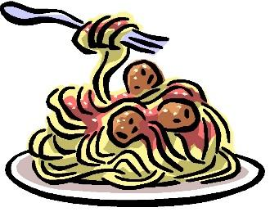
Saturday Nov 23rd 5-7pm
$5 PER TICKET!!!
Wallkill Reformed Church
45 Bridge Street Wallkill NY
50/50 tickets and
Great Prizes to be raffled off!!
*NU CAVU *P&G’s *McGILLICUDDY’S * *TOPS MARKET
*FREE CAKE from CAKES BY BARBARA *LaBELLA RESTAURANT
*TOSCO’s PIZZA *MOUNTAIN BRAUHAUS * PLAZA DINER
*MAGNANINI Gift Basket *HANNAFORD Gift Basket *VERIZON
Come support the scouts!!!

